

**J. Gruodzio g. 21, LT-44293 Kaunas, Lithuania**

**Tel.: (+370 37) 302702 / Fax. (+ 370 37) 302700**

**E-mail:** [**office@santakahotel.eu**](mailto:office@santakahotel.eu)

[**www.santakahotel.eu**](http://www.santakahotel.eu)

**HOTEL RESERVATION FORM**



**For guests of 76th Meeting of UBC Executive Board**

**Kaunas, Lithuania**

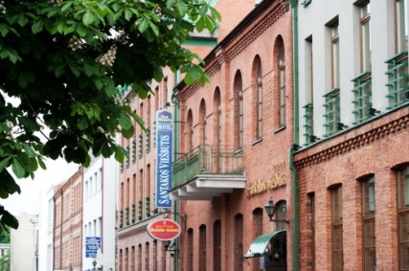 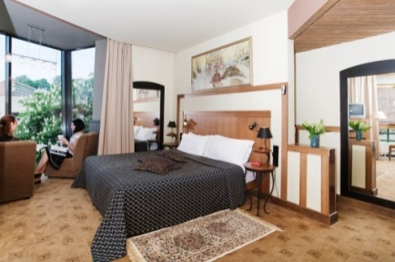 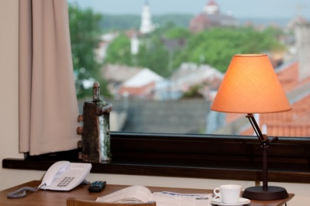

|  |  |
| --- | --- |
| **LAST NAME:** |  |
| **FIRST NAME:** |  |
| **ADDRESS:** |  |
| **PHONE :** |  |
| **E-MAIL:** |  |
| **ARRIVAL DATE:** |  |
| **DEPARTURE DATE:** |  |

|  |  |  |  |
| --- | --- | --- | --- |
| **ROOM TYPE** | **RATE** | **PLEASE CHOOSE ROOM TYPE** | **PLEASE SPECIFY NO. OF ROOMS** |
| **STANDARD SINGLE** | 50 EUR |  |  |
| **STANDARD DOUBLE OR TWIN** | 60 EUR |  |  |
| **SUITE SINGLE** | 66 EUR |  |  |
| **SUITE DOUBLE OR TWIN** | 78 EUR |  |  |
| SPECIAL NOTES / REQUESTS:  ***please*** *indicate all food allergies and intolerances* | | | |

***Room rate includes full breakfast, sauna and swimming pool (from 7:00 till 10:00 a.m.), use of business center (computer, printer, fax), Wi-Fi access, car parking place and VAT.***

*The city tax – per person from 18 years old - 0.50 EUR per person and night (this fee is not included into the room rate).*

* *Check-in starts from 14:00; check-out until 12:00.*
* *Guaranteed reservation can be cancelled without any charge 24 hours before arrival date.*
* *In case of NO SHOW without any warning, the Hotel charges 100% of room rate per night.*
* *Please note that this form does not guarantee a reservation. Reservations will be confirmed upon availability.*

**WE KINDLY ASK YOU TO SEND US YOUR CREDIT CARD INFO TO GUARANTEE THE RESERVATION:**

VISA  American Express  Eurocard/Mastercard

Number:       Expiry date:

## PLEASE SEND US THIS FORM BY FAX +370 37 302700 OR E-MAIL conference[@santakahotel.eu](mailto:office@santakahotel.eu).

**Visit our website for more information about the hotel:** [**www.santakahotel.eu**](http://www.santakahotel.eu)**.**

**CHOOSE THE BEST!**