Budgets for projects in Interreg Baltic Sea

Budget consists of six categories
Real
Costs

Simplified
Costs
options
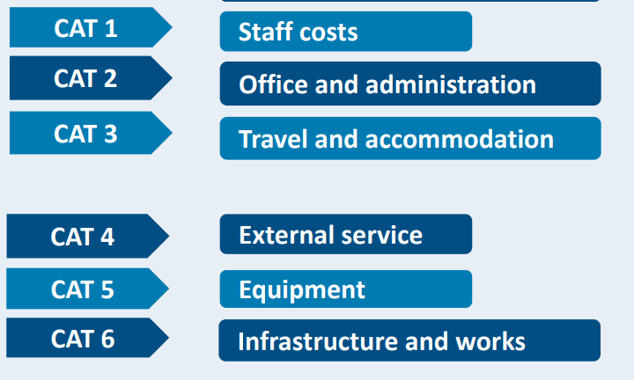

CAT 1. Staff cost
- Based on hourly rates. Different for each participating country.
- Employment contract or equivalent
- 1,720 hours per full-time employee per calendar year
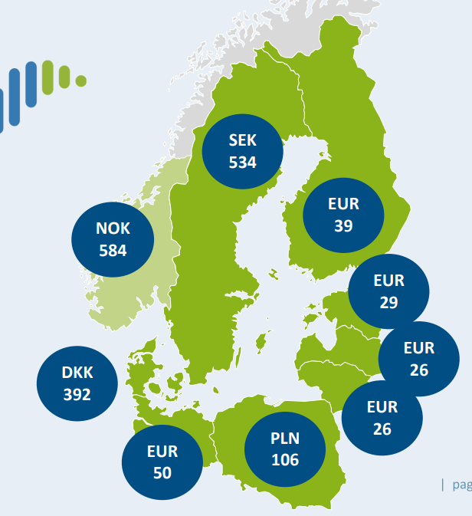

CAT2 – Office & administration
- Flat rate – 15 % of eligible staff costs
- No supporting documents

CAT3 – Travel & accomodation
- Flat rate – 15 % of eligible staff costs
- Project partner’s own employees only
- No supporting accounting documents

CAT4 – External services
- Full costs
Documentation needed to get reimbursement:
- Procurement documentation
- Invoices
- Proof of delivery of services
- Payment proof

CAT5 – Equipment
- Full costs, depreciation/rental/lease

CAT6 – Infrastructure & works
Design and realisation of infrastructure and works
- Full costs

Funding rate
For EU partners 80 %

